CS350_SECTION02_XIAQIN QIU

* 3. 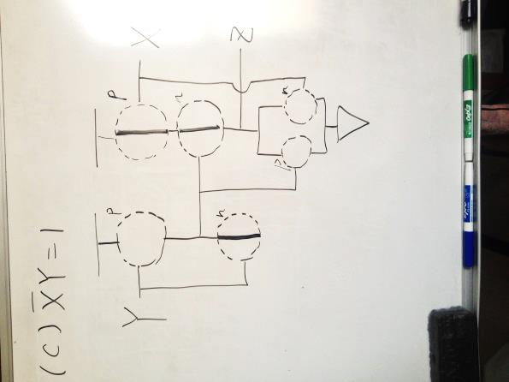

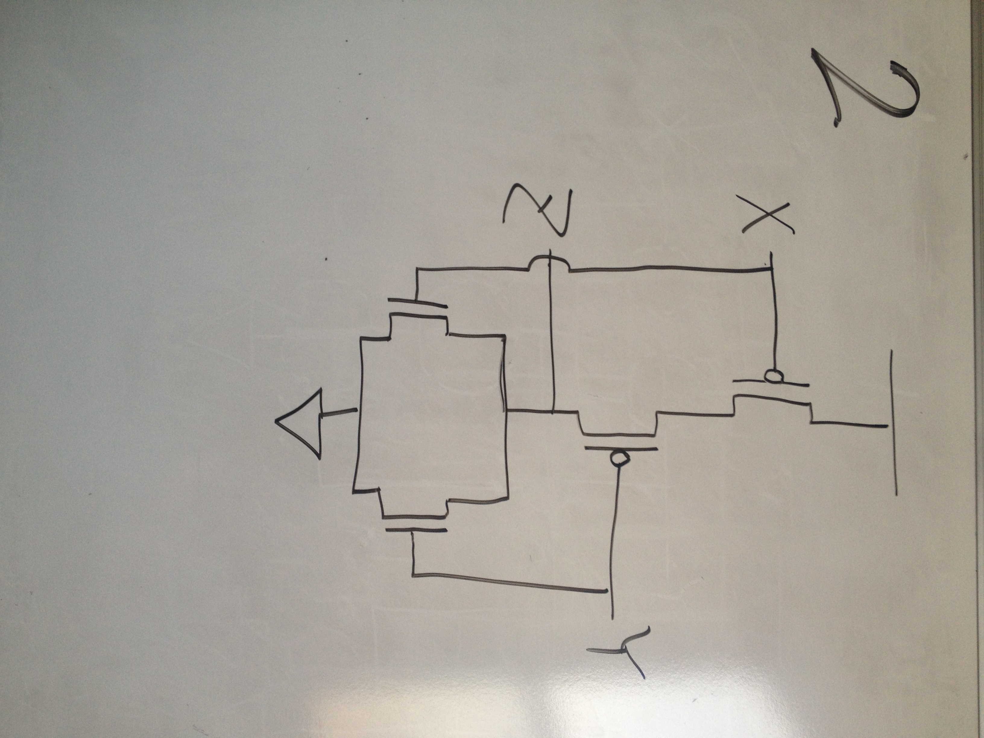

1. 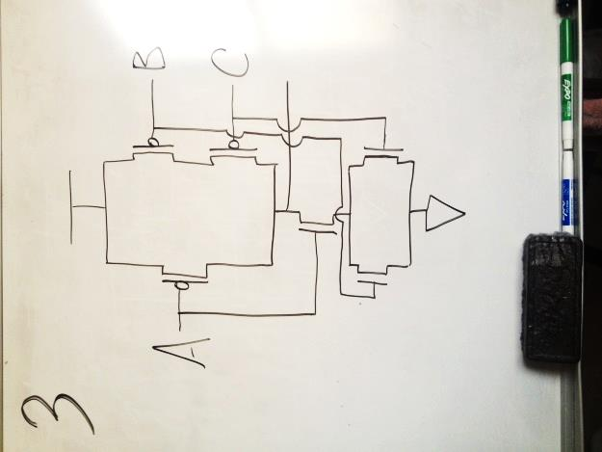
   1. Yes, we get a legal circuit.
   2. It calculates $\overline{A}\left(\overline{B}+\overline{C}\right)$
 $A(B+C)=1$

  3. No, we don’t get a legal circuit.

|  |  |  |  |
| --- | --- | --- | --- |
| A | B | C | Status |
| 0 | 0 | 0 | Z=1 |
| 0 | 0 | 1 | Z=1 |
| 0 | 1 | 0 | Z=1 |
| 0 | 1 | 1 | OPEN |
| 1 | 0 | 0 | OPEN |
| 1 | 0 | 1 | Z=0 |
| 1 | 1 | 0 | Z=0 |
| 1 | 1 | 1 | Z=0 |

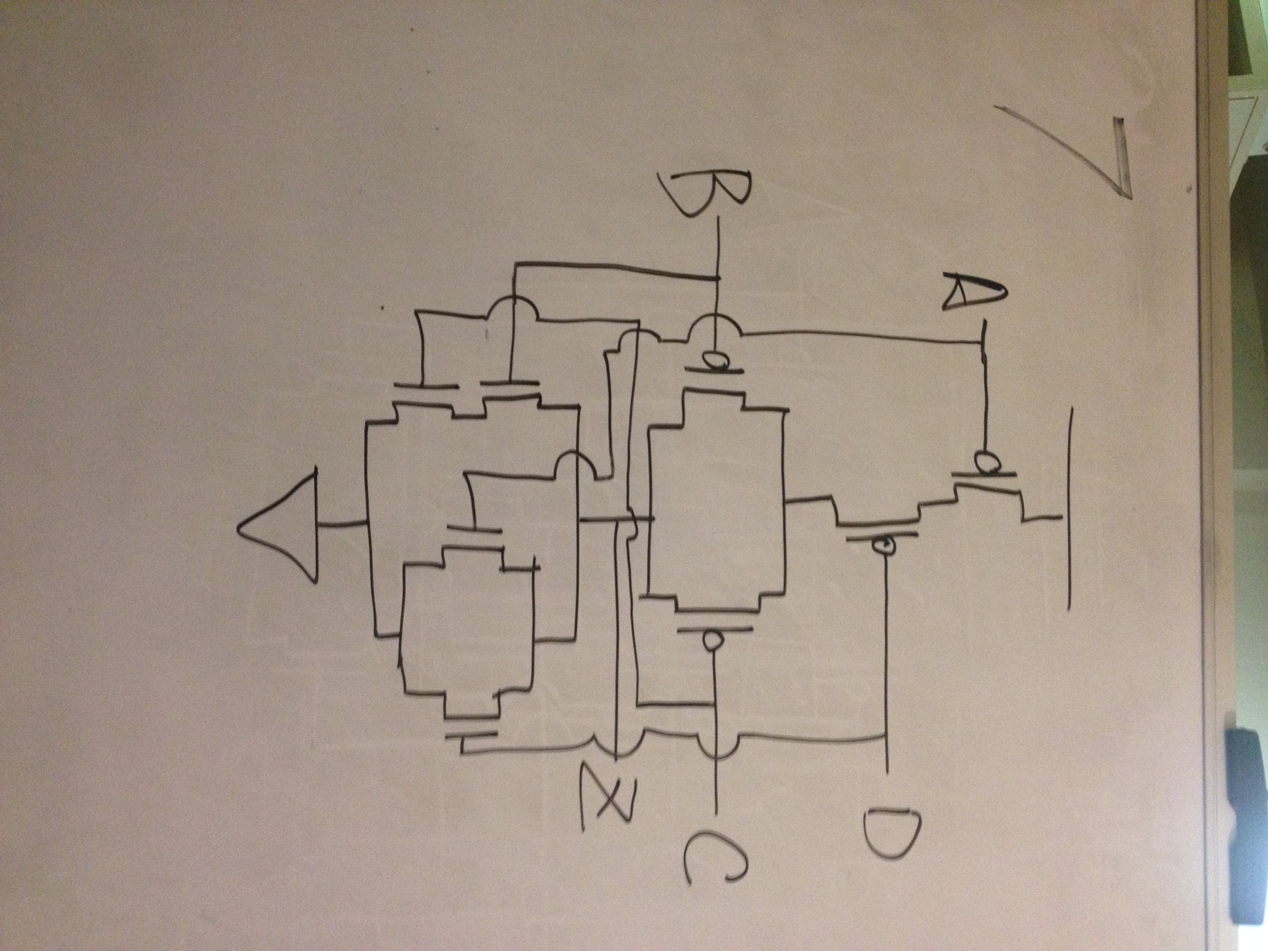

$V=\overline{X\overline{Y}+\overline{Z}} \overline{\overline{Y+Z}+X}$

|  |  |  |  |
| --- | --- | --- | --- |
| X | Y | Z | V |
| 0 | 0 | 0 | 0 |
| 0 | 0 | 1 | 1 |
| 0 | 1 | 0 | 0 |
| 0 | 1 | 1 | 1 |
| 1 | 0 | 0 | 0 |
| 1 | 0 | 1 | 0 |
| 1 | 1 | 0 | 0 |
| 1 | 1 | 1 | 1 |

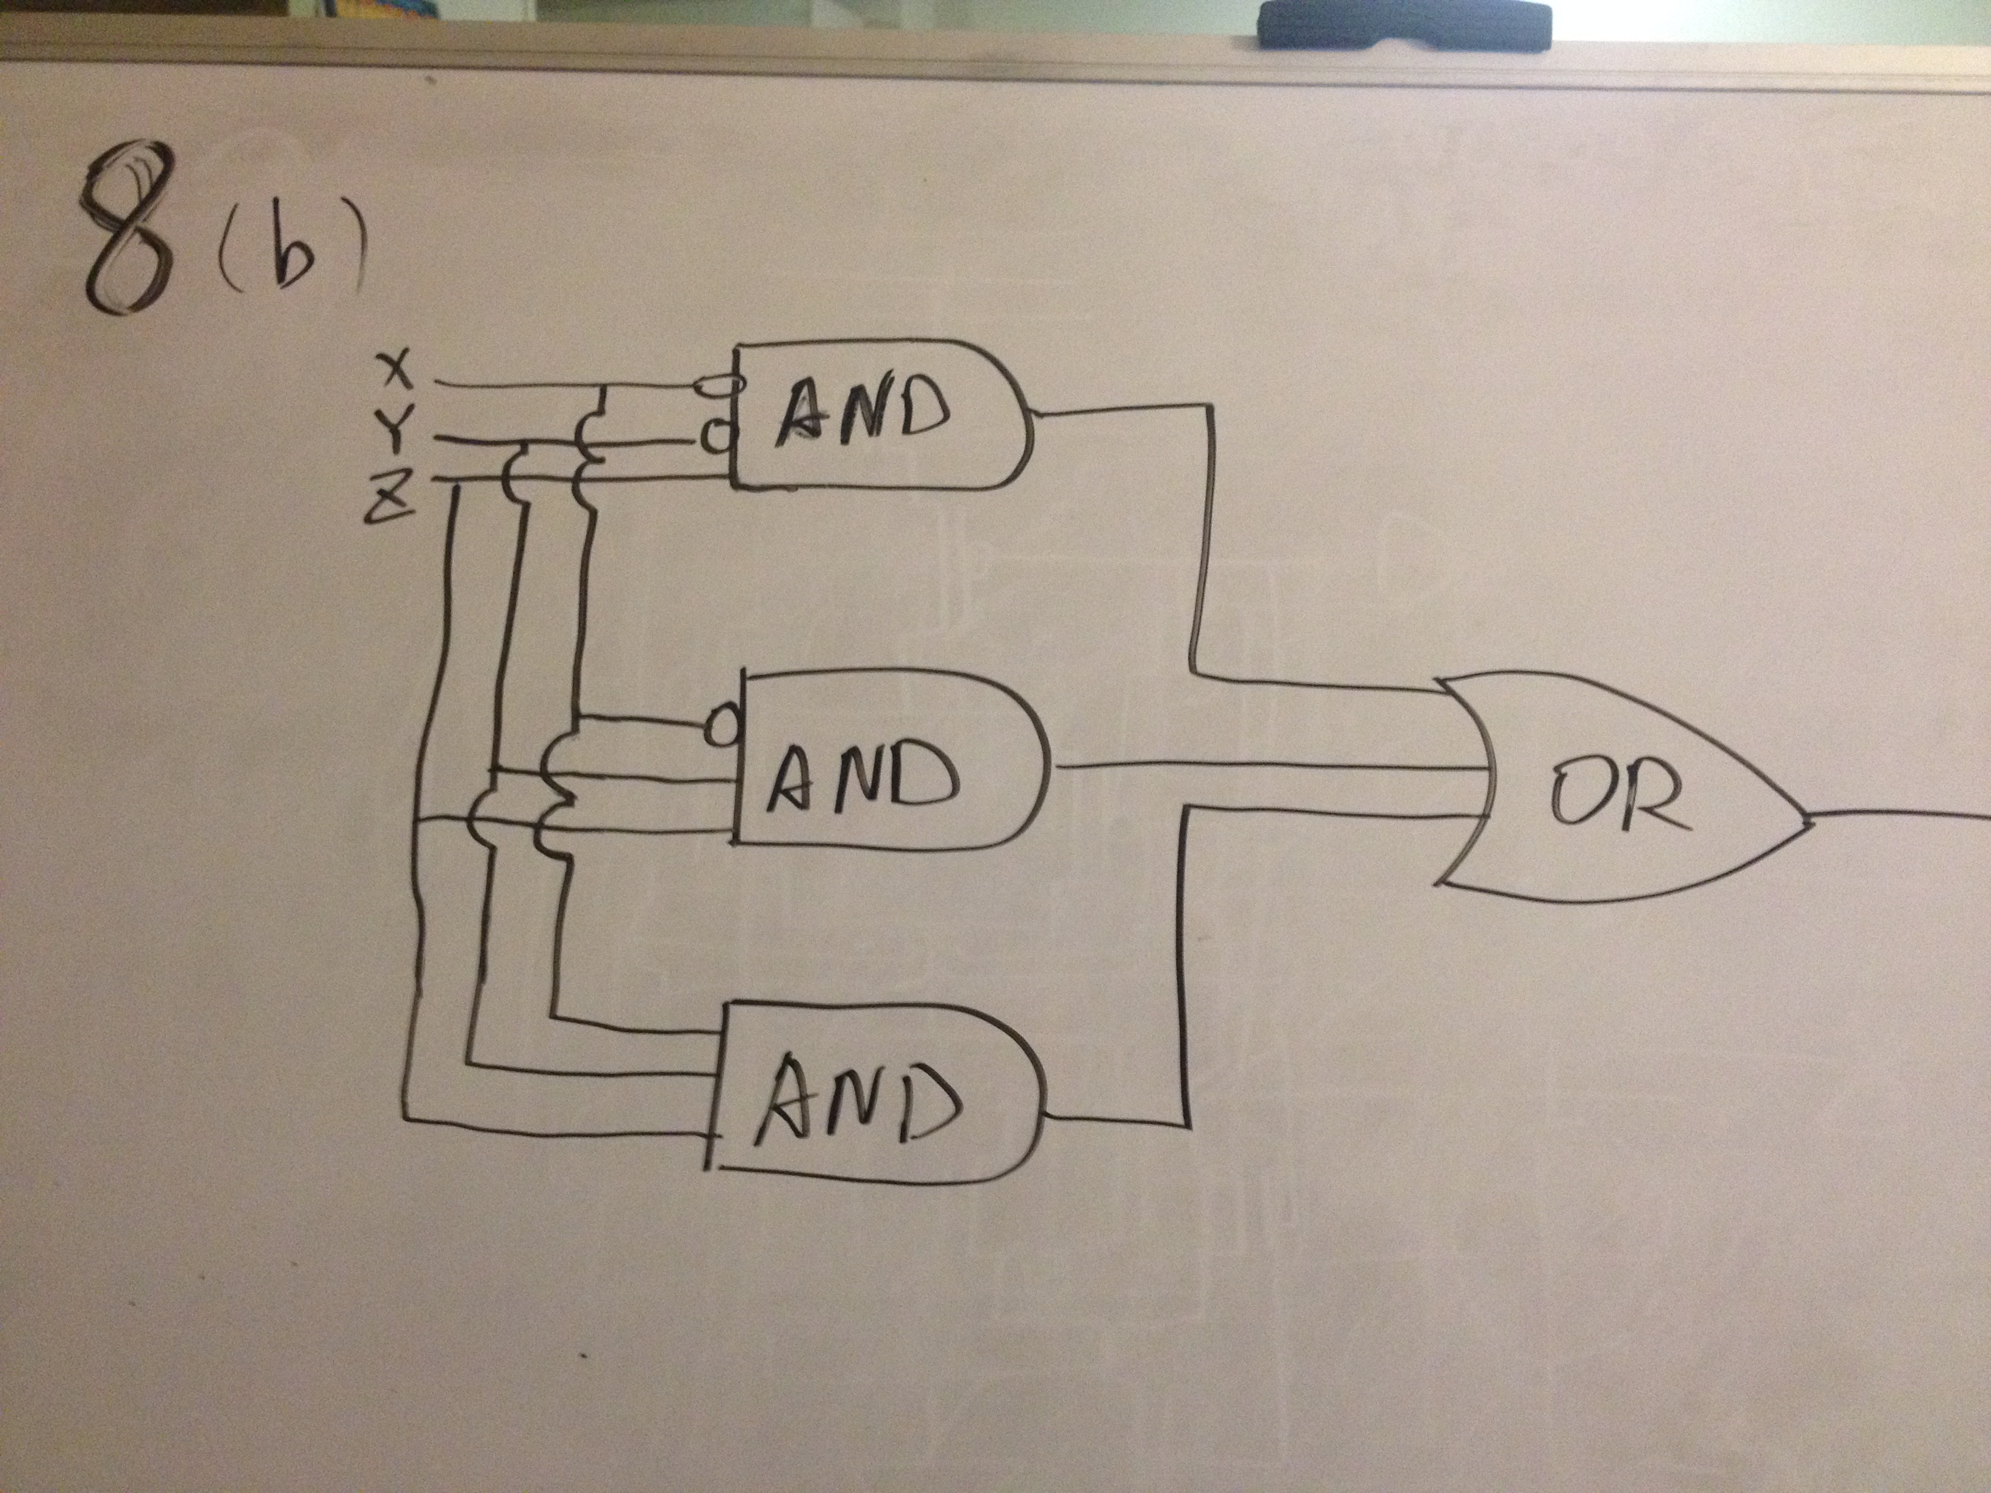

|  |  |  |
| --- | --- | --- |
| XY | Z | |
| 0 | 1 |
| 00 | 0 | 1 |
| 10 | 0 | 0 |
| 11 | 0 | 1 |
| 01 | 0 | 1 |

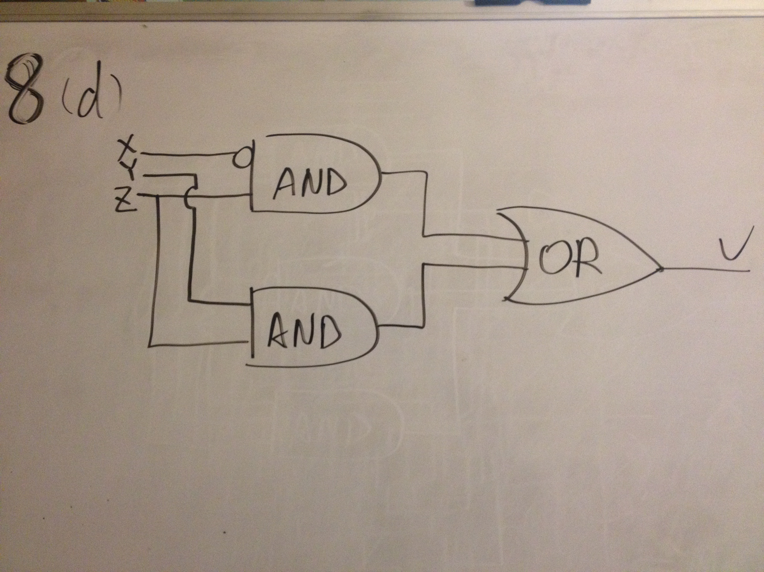

* 1. The wire X inputs to choose B0 or C0 for the multiplexer.
  2. C0: B0

